HUMBERSIDE OCCUPATIONAL HEALTH & SAFETY GROUP
Join us for our next seminar of 2026
(not a member yet? We will host your first session for free)

When: Wednesday 8th April 2026 - 1300* start – 1600 (approx.)
*Session will start at this time, please arrive a little in advance.


'A Journey of Complacency’
presented by Paul J Mahoney
of Inspiring Safety
AND
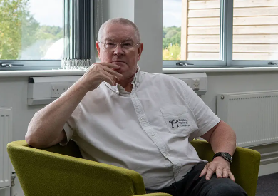
‘An introduction to DISC profiling
and how it can improve behavioural safety’
presented by Rob Knowles
of Cubet Ltd and DISC Simple
Please visit the event page on Linked In and let us know if you will be attending.

Please put this event in your diaries and invite your colleagues and connections.

Location: Latus Group Ltd, Hull Rugby Union Football Club, Ferens Ground, Chanterlands Avenue, Hull, HU5 4EF.

(Please note parking is in the first carpark, next to the Dog Hub. Then walk along the pitch to the left of the buildings until you come to the function room where we will be meeting)

Should you have any questions, please let a member of the HOHSG team know, we look forward to hearing from you, or for further detail, please visit our website www.hohsg.org.uk or our Linked In page https://www.linkedin.com/groups/13352497/

